**Employment Opportunity**

**MD of Wainwright No. 61**

**Summer Students 2024**

The MD of Wainwright is inviting applications for Summer Students for the 2024 season.

Qualified applicants must have a valid Class 5 driver’s license.

**Closing Date is February 9, 2024**

Further details and information may be obtained by contacting the Public Works Shop at 780-842-4024.

We thank all candidates for their interest. Those selected for an interview will be contacted. Please submit applications to:

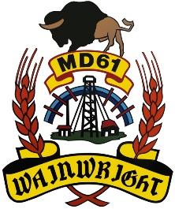MD of Wainwright No. 61

Attention Public Works Shop

2005-14 Street

Wainwright, AB T9W 1K2

Fax: 780-842-4110

Email: safety@mdwainwright.ca